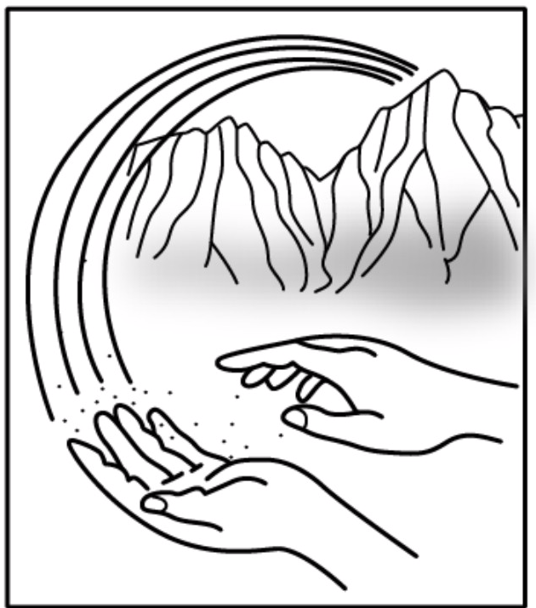
Windward Therapeutic Massage Center
School of Massage Therapy

2010 – 2011 Course Catalog

1 Welcome

2 Student Success
History
Philosophy
Corporate Mission Statement
Purpose Statement
Educational Goals

3-4 Massage Therapy Program Details
Faculty/Student Ratio
Professional Massage Therapy Certificate of Completion
Clock Hour Conversion
Curriculum Progression
Massage Therapy Clinic
Program Hours

5-7 Course Description

8 Admission Requirements
Tour the School
Statement of Non-Discrimination
Enrollment Process
Tuition & Fees
Payment Plans
Financial Aid & Additional Resources

9 Attendance Policies
Grading System

10-11 Leave of Absence Policy
Student Records
Confidentiality of Student Records
Student Code of Conduct
Drug Free Environment
Terms of Dismissal
Withdrawal
Student Complaint & Grievance Procedure
Readmission Policy

12 Tuition & Refund Policies
Cancellation Process & Refund Policies
Collection Policy
Graduation Requirements

13 Campus Information
Faculty and Staff

14-16 Application for Enrollment

American Savings Bank Building
45-1144 Kamehameha Highway
Suite 200 Kaneohe, Hawaii 96744

Tel: (808) 236-1529 Fax: (808) 236-0844
Email address: healingjourney@hawaii.rr.com
Web address: www.hawaiianhealers.com

Welcome to Windward Therapeutic Massage Center School of Massage Therapy

We are pleased that you are considering us as your guide and teacher to reach your career goals in the Professional Massage industry. We are committed and dedicated to helping students achieve a higher degree of knowledge in the massage profession. The Massage Profession is rapidly growing and has become widely embraced by both the public and the medical community. No longer just an enjoyable pastime and means of relieving stress, massage has become an important component in treating many types of injuries, medical conditions and enhancing athletic performance. Massage therapy also provides you the opportunity to heal others and to offer relaxation. There are many paths to reaching your personal goals, and we are grateful that you are considering Windward Therapeutic Massage Center to take part in making your goals a reality.
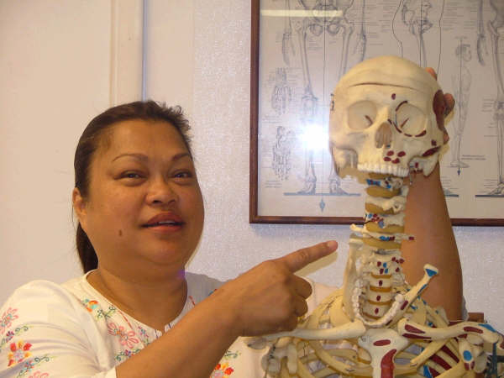
Aloha,
Rochelle Featheran, LMT
Director

Healing Journey…through the power of touch

Student Success
Student success is our focus. Windward Therapeutic Massage Center (WTMC) is
committed to the successful education
of each student who walks through our
doors. Student success is supported
through the availability of individualized learning options, study groups, and job placement opportunities. The ultimate goal of the educational process is to provide our graduates with the skills necessary to realize their professional goals. Student success is supported by the administration and the curriculum at WTMC. WTMC provides guidance during the learning process and also support in identifying employment possibilities.

History
WTMC was established in 1985
in Kaneohe, Hawaii along with Family Chiropractic Center. Arising from a
need for specialized training in massage
therapy and other alternative wellness
techniques, WTMC School of Massage Therapy was developed. The founding premise was to offer an educational program including anatomy and physiology, overlaid with concepts of personal responsibility and holistic practices.

Philosophy
The philosophy of WTMC is to train students
to become qualified and employable in
the field of massage therapy. WTMC
continues to improve the curriculum by
incorporating new techniques into the
existing programs.

Corporate Mission Statement
We are a team of committed, enthusiastic, caring professionals; dedicated to the life principle that health comes from within. Our purpose is to heal and educate our students, patients and the community empowering them to achieve optimum health. We treat people according to their individual needs. Our commitment is founded upon student and patient service, dedication to excellence, and the Aloha spirit.

Purpose Statement
WTMC is committed to providing quality
massage therapy training programs
resulting in competent practitioners in
the profession of massage therapy. The
school provides an environment in which
personal responsibility is stressed in
areas of learning, teaching, and ongoing
professional development. Learning
experiences are based on the value
of personal and professional integrity
and respectful care of individuals in the
learning environment, in the clinic, and
in the community.

Educational Goals
The overall goals of the massage
therapy program at WTMC are the
following:
• to provide a quality massage therapy
training program resulting in competent
practitioners entering the profession of
massage therapy and to educate students in proper business practice and ethics.
• to develop student behaviors
grounded in personal responsibility
through learning experiences, teaching
techniques, and modeling professional
development
• to provide learning experiences that
foster personal and professional
integrity and a commitment to the
respectful care of individuals in the
learning environment, in the clinic, and
in the community.
• to provide an environment where students are able to learn and work on various industrial injuries while assisting our licensed massage therapist.

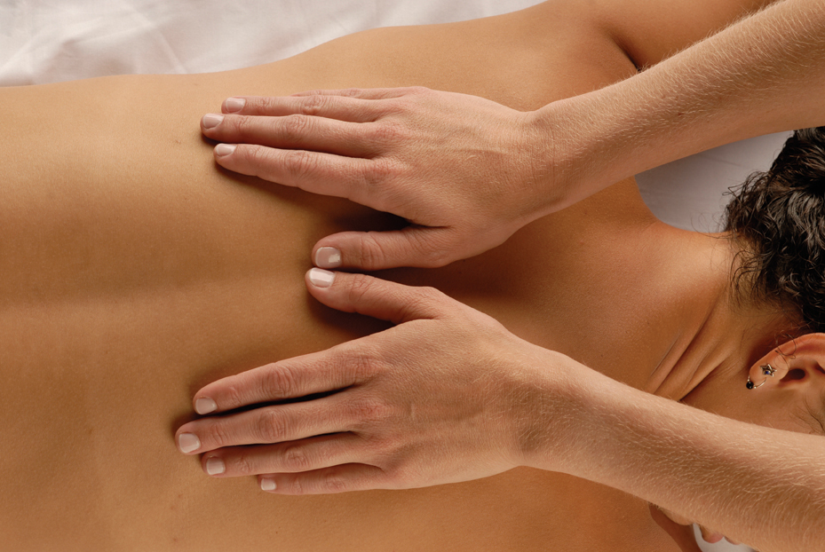

Massage Therapy Program Details

Faculty/Student Ratio
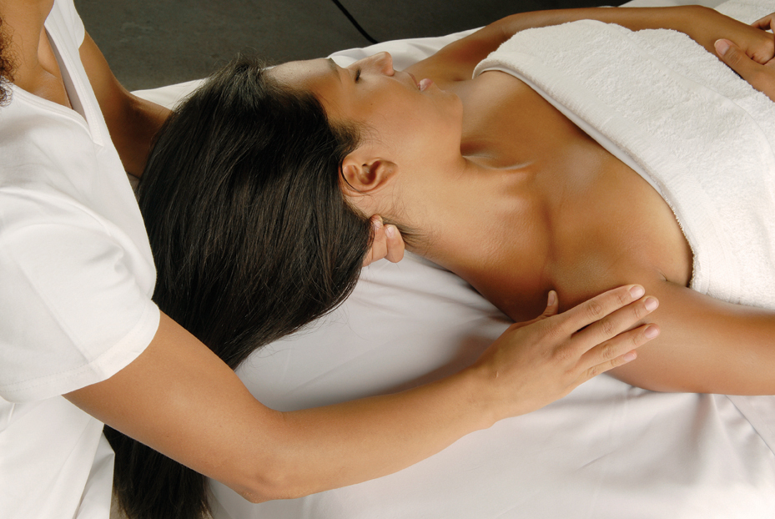
The school maintains a maximum faculty-student ratio of 1:12 in all bodywork classes. The ratio is 1:6 during supervised clinical experiences.

Professional Massage Therapy Certificate of Completion
WTMC offers a Professional Massage Therapy Program which results in a certificate of completion. WTMC’s Professional Massage Therapy Program provides learning experiences that are designed to integrate the knowledge and skills needed for competency in professional massage therapy practice through a program requiring a minimum of 570 hours.

570 Hour Program
A variety of massage therapy techniques are introduced to facilitate the graduate’s ability to address the specific problem areas and concerns clients present.
The Professional Massage Therapy Program is divided into 2 quarters. The progression of the curriculum builds on the knowledge gained in each class. Quarter 1 introduces students to the history of massage, massage theory and practice, anatomy, physiology, and kinesiology, general benefits of massage, the normal functioning of the body, the theoretical principles of therapeutic massage, and the therapeutic relationship along with the opportunity to participate in supervised practice of the application of massage techniques.

At mid-semester, students will have the opportunity to apply massage to the public through a student clinic learning experience. During Quarter II, the student will learn critical thinking while considering client history, client treatment planning, and treatment most likely to benefit the client with specific concerns, as well as the expected outcomes and feedback about what occurred in the clinical experiences. Students will also be educated in hygiene/sanitation, universal precautions, standards of practice, ethics, body mechanics, draping and positioning, specific massage strokes, contraindications to massage, professional and business ethics and recordkeeping. The overall focus is to support the students in developing a strategy for applying massage therapy based on the client’s needs and the student’s ability to carry out the massage therapy strategy and assess its effectiveness.

Clock Hour Conversion
150 Classroom Hours
• 50 hours of Anatomy, Kinesiology, and Physiology
• 100 hours of hands on and theory and demonstration of massage, which will include:
1. The proper procedure in massage, concerning the protection of both the client and the massage therapist
2. Record keeping
3. Hygiene
4. Theory
5. Technique for specific conditions
6. Contraindications
7. Draping
8. Assessment of the client’s condition and the general technique to be applied
420 Apprenticeship Hours
• 70 hours of clinical operation, which will include:
1. Sanitation: Application of department of health regulations, linen, towels-30 hrs.
2. Office Procedures: Answer phone, taking appointments, client rapport-30 hrs.
3. Record Keeping: Client records-10 hrs.

• 40 hours of Advance techniques which will include:
1. Observation of classroom instructors-20 hours.
2. Consulting-20 hours
• 310 hours of hands-on supervised massage with record keeping

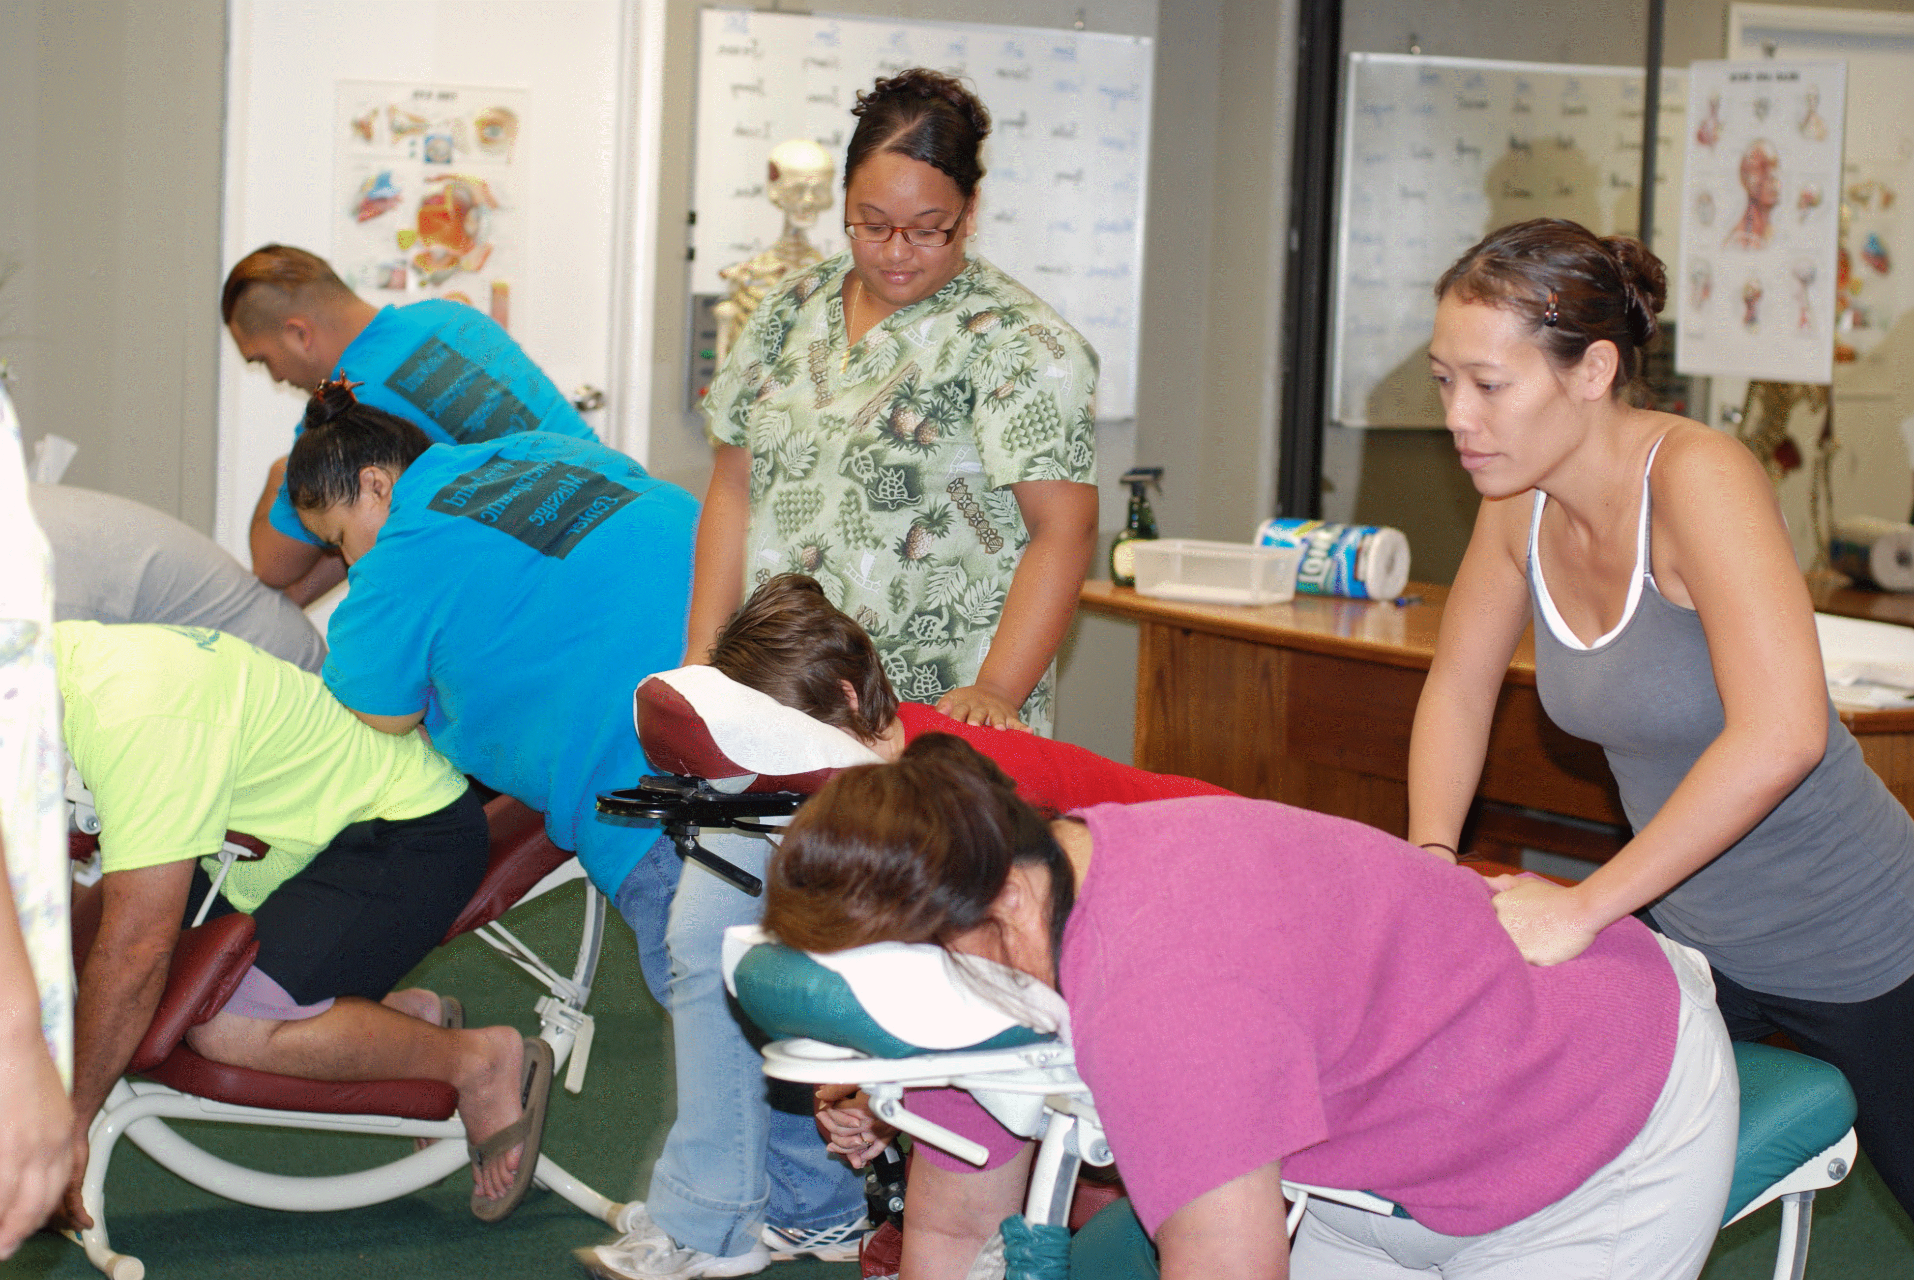
Curriculum Progression
- 100 hours of theory and practice
- 50 hours of anatomy/physiology and kinesiology
- 70 hours of clinical operations
- 40 hours of advanced techniques
- 310 hours- Clinical Apprenticeship. This will consist of hands on supervised massage with record keeping of clinical operations and hands-on supervised massage with record keeping.

Massage Therapy Clinic
The Massage Therapy Clinic is designed to represent the professional job market. Through this course students learn customer service, promptness, and efficient use of time. It offers a challenging clinical experience designed to guide the student practitioners through their transition into professional practice.
This is accomplished through an intense, professionally supervised apprenticeship where students further develop their skills in treating, monitoring and making the necessary recommendations for clients with various pathological conditions. These skills help ensure graduate success in the massage therapy industry. Students have the opportunity to practice acquired skills and gain valuable experience by working with clients from the general public in the clinical apprenticeship.
During this phase of study, each student practitioner is guided by the Clinic Manager through regular conferences regarding treatment preparation, client recommendations, documentation of treatments, the use of specific points and techniques, and the progress of the client. Students give scheduled massages called tutorials to licensed massage therapists and receive valuable feedback.

Program Hours
40-week Program
Monday, Wednesday, and Thursday
6 p.m. to 9 p.m.

Course Description

Anatomy & Physiology
Human Anatomy and Physiology is the
study of the normal structures and related functions of the body systems. The focus of this course is to emphasize the interaction between the body systems and the application of massage therapy. This class begins with information regarding medical terminology to acquaint students with the scientific language that is used to describe various systems and structures.

Kinesiology
The focus of this class is the understanding of human body movement. The course focuses on locations of bones and major landmarks on the bones where muscles attach, as well as the names of muscles, their placement in the body, and the actions that muscle groups produce.
As part of each class period, lecture material is complemented by palpation exercises providing hands-on experience and multimedia demonstrations of bone location, and muscle placement. The study of kinesiology in the context of bodywork is to harmonize the knowledge of body movement with the application of massage therapy strategies.

Massage Therapy Techniques
Trigger Point
Students learn how to identify trigger points in the tissue, recognize their characteristic referral patterns, and how to apply techniques that may release the trigger point, resulting in pain relief.
Students learn the indications for trigger point manipulations and the use of heat and cold as a tool in the treatment strategy.

Swedish
Swedish massage is taught as the basic strategy in providing clients with relaxation and stress reduction. Students learn to relax muscles by applying pressure to them against deeper muscles and bones, and rubbing in the same direction as the flow of blood returning to the heart. The main purpose of Swedish massage is to increase the oxygen flow in the blood and release toxins from the muscles.

Shiatsu
Students are introduced to the Asian philosophy of health which provides the theoretical framework for various forms of Asian bodywork. Students are taught to recognize the interaction between the physiologic and energetic imbalances. The course provides an introduction to the application of Shiatsu and acupressure as a technique in working with these imbalances.

Reflexology
Students learn to manipulate those reflex areas in hands, feet, and ears that correspond to organs and specific areas of the body. The course assists students in understanding how structure and function are interrelated and how bodywork affects the entire organism.

Pre-Natal Massage
Students learn how to apply pre-natal massage techniques for pregnant women while explaining the physiology at the different stages, safe approaches to massage therapy, offering increased circulation, relaxation, and relief from discomfort from the physical and emotional changes taking place during pregnancy.

Chair Massage
Students learn strategies to use with clients when using a massage chair rather than a table. And workplace strategies to offer massage to employees on-site at the office.
Chair massage or seated massage, is a strategy that allows the student to learn and apply therapeutic massage techniques to clients who are fully clothed in a seated position. This form of massage application is an effective method of
providing massage in the workplace and other public venues.
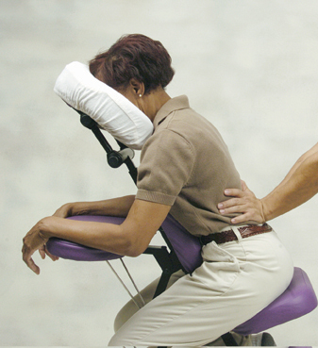
Sports Therapy
Sports Massage prepares students to address basic needs of the athletes. Multiple techniques are taught to enhance athletic performance, prevent injury, and improve recovery time.

Deep Muscle Tissue
Students learn to differentiate between superficial and deep tissue, and how to safely deliver appropriate deep pressure based on a client’s needs. Emphasis will be placed on depth and adjustment of pressure and learning to increase the intelligence of the hands through touch.

Additional Courses include: Pressure Point, Energy healing Techniques, Hot rock therapy, and Essential Oils.
Theory and Practice
• Self care – body mechanics
• Positioning clients for comfort
Students will be guided in the importance of human touch and the healing process based upon the body’s response to the application of touch.
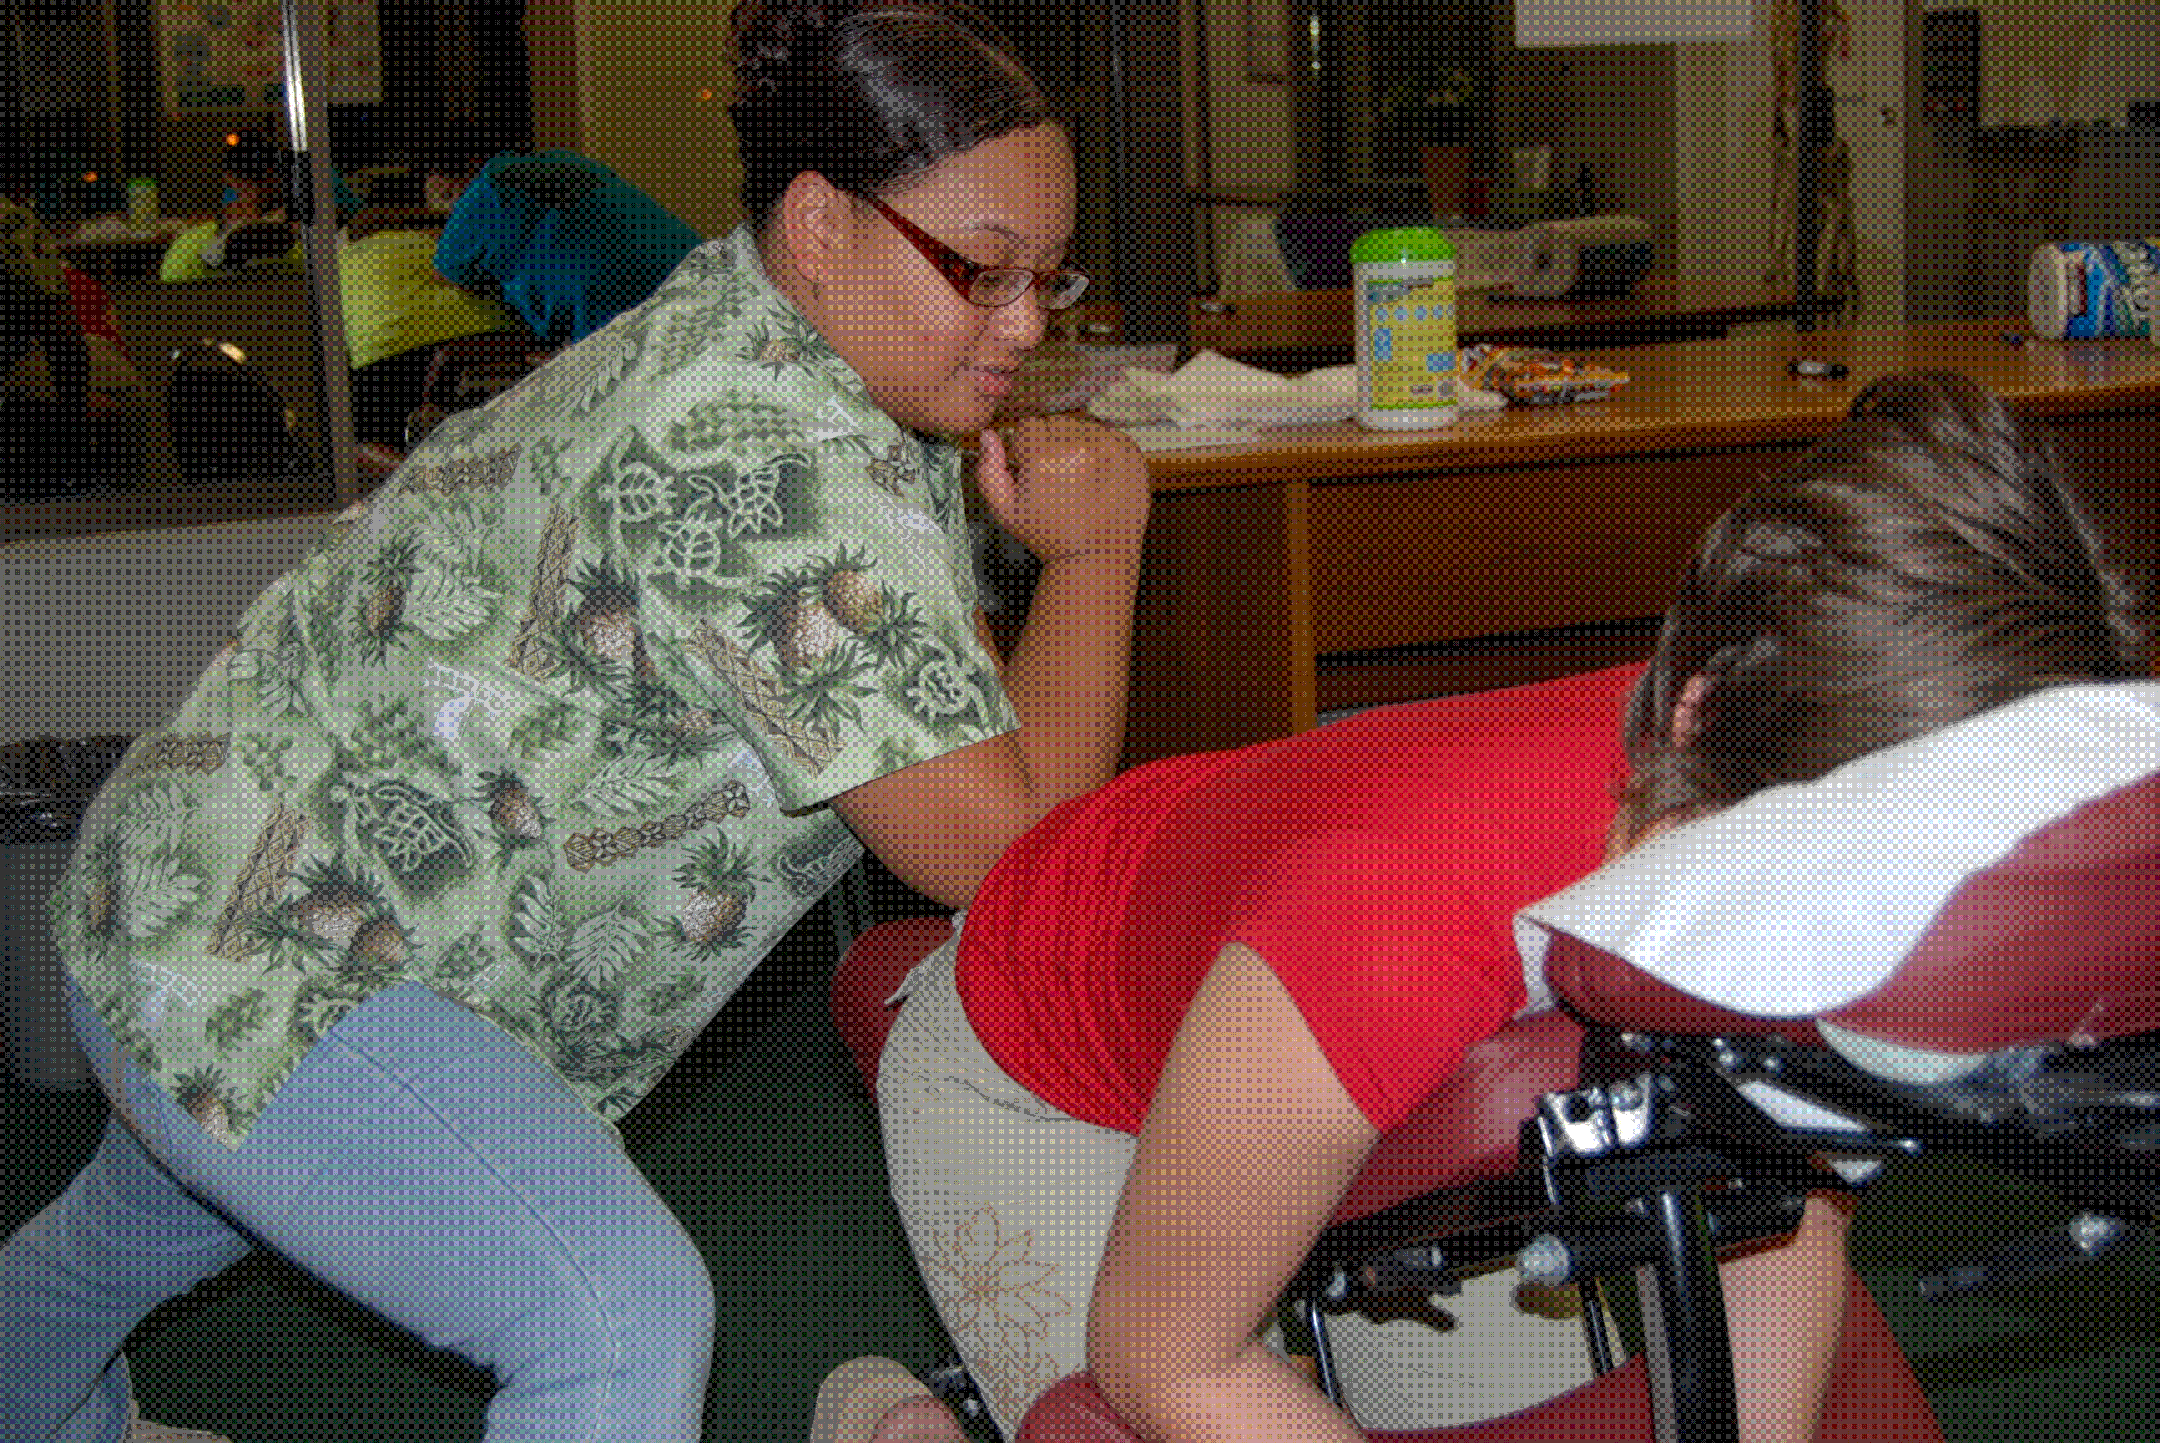
This course provides an introduction to indications and contraindications for massage therapy and facilitates the development and improvement of palpation skills so essential to the massage therapist. Classroom practice includes giving and receiving massage with fellow students under direct faculty supervision. Students learn modalities and how to augment massage strategies that address client concerns. The students receive demonstration and opportunities to practice the massage strategies and receive feedback on their body mechanics to achieve the optimal application of massage therapy strokes and strategies.

Functional Assessment
• Postural assessment
• Tissue assessment
• Pain assessment
Students begin to develop specific skills in identifying the effects of muscle imbalance through tissue assessment, postural assessment, and pain assessment within this course. Students learn how to assess clients, provide information to indicate the treatment approach, and to assess the outcome of the specific session. These skills progress as the students apply the tools in each modality taught.

Hydrotherapy
• Hot and cold therapy Students are introduced to the physiological and reflexive results of applying heat, cold, and alternating heat and cold as part of massage therapy sessions. Students have the opportunity to apply heat and cold as part of an
integrated approach to a client treatment session during the clinic experience.

Joint Mobilization, Stretching, and Range of Motion
• Assessment of joint movement
• Passive stretching as an element of
massage therapy sessions
• Range of motion to enhance movement
By assessing joint mobility, students learn the effect of various tissue restrictions in limiting joint movement. Students build upon the knowledge gained in kinesiology to integrate the available
joint movements into a massage therapy routine. They also learn how to enhance mobility when a joint is restricted due to soft tissue tightness through use of techniques such as contract-relax. This course element provides a focus on specific areas of concern within the soft tissue of the body. Basic orthopedic tests are introduced to enhance the students’ ability to determine indications and contraindications for massage. The students learn strategies that integrate different approaches to address the client’s condition using an integration of various techniques for optimal therapeutic success.

Conditions include:
• Whiplash
• Carpel tunnel syndrome
• Thoracic outlet syndrome
• Low back pain and sciatica
• Postural distortions and scoliosis
• Rotator cuff syndrome
• Repetitive strain disorders

Connective Tissue Massage
• Myofascial release
• Connective tissue stretching
• Massage therapy techniques that address connective tissue tightness Students learn the properties of connective tissue and how it affects movement throughout the body. Specific techniques are taught that have a direct effect on connective tissue. These techniques and the information gained through various assessment strategies are then integrated into a therapeutic massage.

Sprains and Strains
Students are trained to apply pre- and post-event massage on athletes. The course provides information about the various responses to exertion, such as muscle cramps and spasms, and the criteria to identify concerns that are indicative of heat exhaustion and heatstroke. Students also receive training in the interface between the massage therapist and athletic trainers working at sporting events, and specific knowledge about the soft tissue development of athletes.

Performance Assessment
Students are each assigned an instructor who will evaluate their massage therapy skills and progress through individual massage sessions four times throughout the course. This provides students the opportunity to receive individual
feedback that refines their skills as a massage therapist based upon the knowledge and skill learned in that segment of the course. These assessments occur at the midpoint and the end of each semester. Satisfactory achievement of each assessment is required to continue in the program. These are scheduled outside of class time.

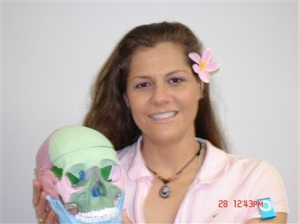

Personal and Professional Development
This class is an introduction to
professional standards of behavior
and interaction within the practice of
massage therapy. The focus of this class
is to prepare the student for therapeutic
client interactions and practice behaviors
for actual client interactions. The topics
include developing oneself as the
embodiment of a professional therapist
and developing a professional therapeutic
relationship. This course also includes: developing a business plan, record keeping, health and sanitation, self care for the therapist, and business and professional ethics

CPR
Adult and child CPR techniques
are taught as outlined by the American
Cross. Students are required to
have current certification at the time of
graduation in preparation for licensure
within the State of Hawaii. Classes are
taught on-site by instructors certified by
the American Red Cross.

Clinical Apprenticeship
Students are required to engage in
Clinical experiences under supervision
of faculty in the student clinic and
in fieldwork experiences. The clinic
experience is provided in a professional
clinic environment and is part of the
integration of the knowledge and
skill expected of students during the
progression of the course. Clinic and
fieldwork occur outside of the regularly
scheduled class times.

Admission Requirements
Any person who meets the following requirements is an eligible applicant for WTMC’s School of Massage Therapy Professional Massage Therapy Program:
• is at least 1 8 years of age, or beyond the age of compulsory attendance with the written approval of a parent or legal guardian
• submits a completed WTMC application and fee prior to the day of orientation
• submits a copy of a high school diploma, state certification, or General Equivalency Diploma (GED), or transcripts from the most recently completed high school or post-secondary education, and have evidence of previous satisfactory academic performance. If transcripts for 60 or more semester credits of post secondary school are submitted, high school transcripts are not required. The school reserves the right to start a student on academic probation based on previous academic performance.
• applicant is in good physical, mental, and emotional health and is physically able to give and receive massage with no adversity to her/his health and has the physical capability of providing massage

• is capable of effective interpersonal communication
• has evidence of a negative TB skin test within the last year or has other evidence of being free of active tuberculosis. In addition, the school suggests that students have a Hepatitis B vaccination.
• attends the mandatory orientation program which is scheduled for all new classes prior to the first day of class.

Tour the School
WTMC School of Massage Therapy provides school visits by appointment and regularly scheduled open houses. This gives prospective students the opportunity to tour the school and ask any questions that might arise. To participate in a school visit, please call and schedule a tour.

Statement of Non-Discrimination
WTMC School of Massage Therapy admits students to all privileges, programs, and activities generally made available, without regard to sexual orientation, age, disability, color, gender, race, ethnicity, place of origin, or religion. WTMC does not discriminate on the basis of race, color, national or ethnic origin, gender, sexual orientation, religion, age or disability in administration of the educational policies, admission policies, and other school administrated programs.

Tuition and Fees
$6,000.00-Tuition includes textbooks, handouts, lotions, Massage table and Apprenticeship Fee.

Payment Plans
WTMC School of Massage Therapy offers an optional interest-free payment plan for students who choose not to pay their educational costs in full at registration. Payment options may be tailored for the student on an individual basis with no additional fees.

Financial Aid and Additional Resources
Students may be eligible for additional resources such as:
• Private scholarships
• Sallie Mae, other private educational loans, or Wells Fargo
• Veteran Benefits
• Vocational Rehabilitation
• Alu Like, Inc.
• Oahu Worklinks
The school will cooperate in the completion of all necessary forms but plays no part in determining a student’s eligibility.
Visa and MasterCard are accepted. WTMC does not charge an additional financing fee for use of Visa or MasterCard.

Attendance Policies
Employers of WTMC graduates have an expectation of professional behavior and dependability. As part of our purpose, WTMC believes in preparing students to be responsible practitioners. Consequently, attendance is essential. Additionally, there are two other significant reasons for good attendance. First, poor attendance puts a burden on both the class and the instructor, who must answer questions and repeat class material already covered. Second, the benefits the student receives from good attendance are seen in enhanced job opportunities and graduating with one’s class.

Absences
Students are expected to attend all scheduled class hours. We all notice a difference in the energy when someone is absent. We ask you to honor your instructor, your classmates and the group process with your presence and your focused attention. A student is considered absent after 15 minutes of a class hour has elapsed. Students are required to make up all class hours missed, both excused and unexcused, to maintain 100 percent attendance. This is done by making arrangements with the appropriate staff member. All absences within a specific class must be made up prior to taking the final exam for that semester. Extended absences from any portion of the semester will require the student to repeat the course the next time it is offered. Student records include the actual number of attended class hours. Please note that 3 accumulated absences will be grounds for dismissal with no refund. Please call WTMC at 236-1529 before the class begins to let your instructor know you will be absent.

Tardiness
Class hours are expected to start on schedule with all students in attendance. Students are considered tardy after the class hour has begun. Partial attendance at 3 classes (come late or leave early) is equal to 1 absence. Please call WTMC at 236-1529 before the class begins to let your instructor know you will be tardy.

Grading System
The following grading system is used in all courses:
A= 93-100%
B= 85-92%
C= 75-84%
D= 70-74%
F= Below 69%

Making up Hours
It is the student’s responsibility to make up all hours missed, and the work assigned within those hours, at the current cost of tuition per hour for 150- and 420-level courses. Any hours missed from a 570-level hour course will require that the student repeat the class missed at the cost of that individual class. If class is cancelled due to inclement weather or other unforeseen circumstances, there will be no charge for hours to be made up.

Probation
Any student who is determined to be “at risk” based on grade point average and overall performance will be placed on probation for a period not to exceed 60 days and ending on or before completion of the first half of the program, 150 hours for the 570-hour core massage therapy diploma program. E ach student placed on probation will be required to both follow the plan of action developed to suit their particular needs and to achieve the specific goals set to measure progress. All students remain eligible for financial aid during the probationary period. Students who successfully meet the objectives of the plan of action will continue to be in satisfactory academic progress status.

Leave of Absence Policy
Temporary interruptions in a student’s program due to medical or personal reasons may be allowed through the process of a leave of absence. The United States Department of Education has imposed strict regulations in regard to the allowable time frame for an approved leave of absence which can be up to six months (180 calendar days). The leave of absence request must be submitted in writing to the school Director and approved by the school. In the event that a student has already taken a leave of absence of 180 days and is then faced with another emergency, the federal regulations require that the student officially terminate from school; however, the student then has the option to re-enroll. If a student does not give notice of termination and does not attend school for a period of two consecutive class dates, the school will enact enrollment cancellation procedures (in the case of VA students, the school must notify the VA office after ten (10) consecutive days of absence and the student’s VA benefits may be interrupted and/or the student’s enrollment may be cancelled). The school will advise the student of the affect of a leave of absence on their grace period for those students who have received federal loans.

Student Records
WTMC-School of Massage maintains student records in a secured manner, accessible only to authorized personnel and to students by appointment. The record serves as the primary means for documenting the students’ educational experience while in attendance at WTMC. All student records are permanently on file in the school administrative office. A permanent student record includes, at a minimum, records of the dates of entry and departure, program of study, credits, and grades. To obtain an official academic transcript, students must send $25 with a written request. The student’s account must be paid in full prior to the release of the transcript.

Confidentiality of Student Records
WTMC provides privacy and protection concerning information in student files in accordance with the Federal Family Education Rights and Privacy Act. Student records are confidential and are accessible only to the individual student, or in the case of a minor, the parent or legal guardian, the administrative and teaching staff, and the regulatory and accrediting agencies. Students may inspect and review their
educational records within 4 5 days of presenting a written request to the corporate office. After reviewing the records, if a student believes that the records contain errors or are inaccurate or misleading, she or he may request that the records be amended. All files must be reviewed under the supervision of a Windward Therapeutic Massage Center administrative staff member.

Student Code of Conduct
WTMC represents honesty and integrity in the health and wellness industries and in the community. These philosophies are the basis of our business and service ethics and are expected of all staff and students. It is important to the school that the conduct of all students is governed by a set of rules and that these rules are enforced. Accordingly, a student may be placed on probation, suspended, or terminated from WTMC for unsatisfactory academic or attendance progress or for violation of the Student Code of Conduct as listed WTMC Schools application

Drug Free Environment
WTMC is a drug free environment. Information related to the effects of alcohol and drugs, counseling, rehabilitation programs, and penalties related to illegal possession of a controlled substance are available from the Campus Coordinator and are outlined in the Student Handbook.

Terms of Dismissal
A student may be dismissed for violating the attendance policies or student performance expectations or for failing to maintain satisfactory progress.

Withdrawal
WTMC requires that a student (or parent or guardian if the student is under 18 years of age) give notice of withdrawal to the Campus Coordinator or the Administration and Student Affairs Coordinator. A student shall be deemed to have provided formal notice of intention to withdraw by failing to attend classes for a period of two (2) consecutive scheduled class dates without providing, prior to or during that period, an explanation to the Campus Coordinator and/or Student Affairs Coordinator regarding the absences. A student who fails to attend classes or to return from a leave of absence as scheduled, and who does
not provide formal notice of withdrawal, will be terminated from Windward Therapeutic Massage Center at the end of the school day on the second (2nd) day of unreported absence.

Student Complaint & Grievance Procedure
These procedures provide students with a vehicle to communicate concerns or complaints about faculty, staff, or administrative procedures and receive a fair hearing or resolution to the problem presented. The following is the process to be followed in communicating a concern:
1. Talk directly to the person involved.
2. If the situation is not resolved and involves faculty or staff, contact the WTMC Coordinator. If the situation is not resolved and/or the WTMC Coordinator is the staff member involved in the complaint, a meeting with another member of administration will be arranged. If the situation is with another student or the student’s disciplinary process, the situation should be taken to administration. A response to a written complaint will be made within two weeks of receipt.
3. If a student does not feel that the school has adequately addressed a complaint or concern, the student may consider contacting the Department of Commerce and Consumer Affairs (DCCA). All complaints considered by the DCCA must be in written form, with permission from the complainant(s), for the DCCA to forward a copy of the complaint to the school for response. The complainant(s) will be kept informed as to the status of the complaint as well as the final resolution by the DCCA.

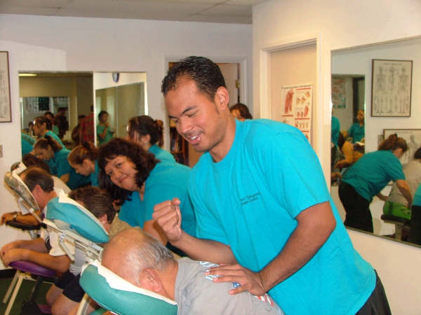
Readmission Policy
1. A student who withdraws may reapply. Payment of a $50 application fee and completion of a new application form is required. Additional class hours will be charged at the rate of the current tuition upon re-entry. The student needs to schedule an interview with the Director or the Administration Coordinator.
2. A student who fails to meet academic or attendance requirements must re-apply and may be readmitted based on an interview with the Campus Coordinator or the Administration and Student Affairs Coordinator.
All successfully completed classes will be credited if the readmission was within six months of the end of the student’s previous course. Payment of a $50 application fee and completion of a new application form is required. Additional class hours will be charged at the rate of the current tuition upon re-entry.
3. A student dismissed for unsatisfactory conduct will not be considered for readmission.

Tuition and Refund Policies

Cancellation Process and Refund Policy
1. Cancellation within three business days: if a student cancels his or her enrollment in writing or in person within three business days after signing the enrollment agreement and prior to entering class, all monies collected shall be refunded, less the application fee, within 10 business days.
2. Cancellation for students who have not visited or toured WTMC prior to enrollment: students who have not visited the school facility prior to enrollment will have the opportunity to withdraw without penalty before midnight of the third business day following either the scheduled orientation or a tour of the school facility and inspection of equipment.
3. If a student cancels his or her enrollment or is dismissed after three business days after signing the enrollment agreement, but prior to entering classes, she or he will be entitled to a refund of all monies paid to the school, less an application fee of $50.
4. If a student withdraws or is dismissed from WTMC after 60 percent of calendar days in the current enrollment period, no refund will be granted. The school will refund prepaid amounts for books and supplies unless the student has consumed or used those items and they can no longer be used or sold to new students or returned by the school to the supplier. WTMC charges a 15 percent restocking fee for any returned books. Application fees are only refunded to students who are not accepted by WTMC. This fee is not included in the refund calculation for any of the programs offered by WTMC.

Collection Policy
In the event that a student fails to meet their tuition obligation as outlined in the enrollment agreement, the amount may be referred to an agency for collection.

Graduation Requirements
Each student must satisfy all required academic and financial obligations including the following:
• successful completion of all course requirements and attendance of 100% of course hours in each quarter
• demonstration of an average proficiency of at least 70% in each subject/class
• successful completion of all classroom assignments, clinic, fieldwork requirements, and performance assessments
• completion of all make-up time prior to the final examinations and the final bodywork evaluations
• participation in an exit interview conducted by a school staff member
• payment in full of any and all accounts or outstanding debts with WTMC two weeks prior to graduation
• all materials borrowed from the school, e.g. library books, magazines, software, equipment, and other learning materials, must be returned to the school in clean and proper condition, or payment for the materials must be made to the school
• completion of all class requirements within 150% of the length of the course
• current certificate of adult CPR and First Aid training TB skin test must be current at the time of graduation

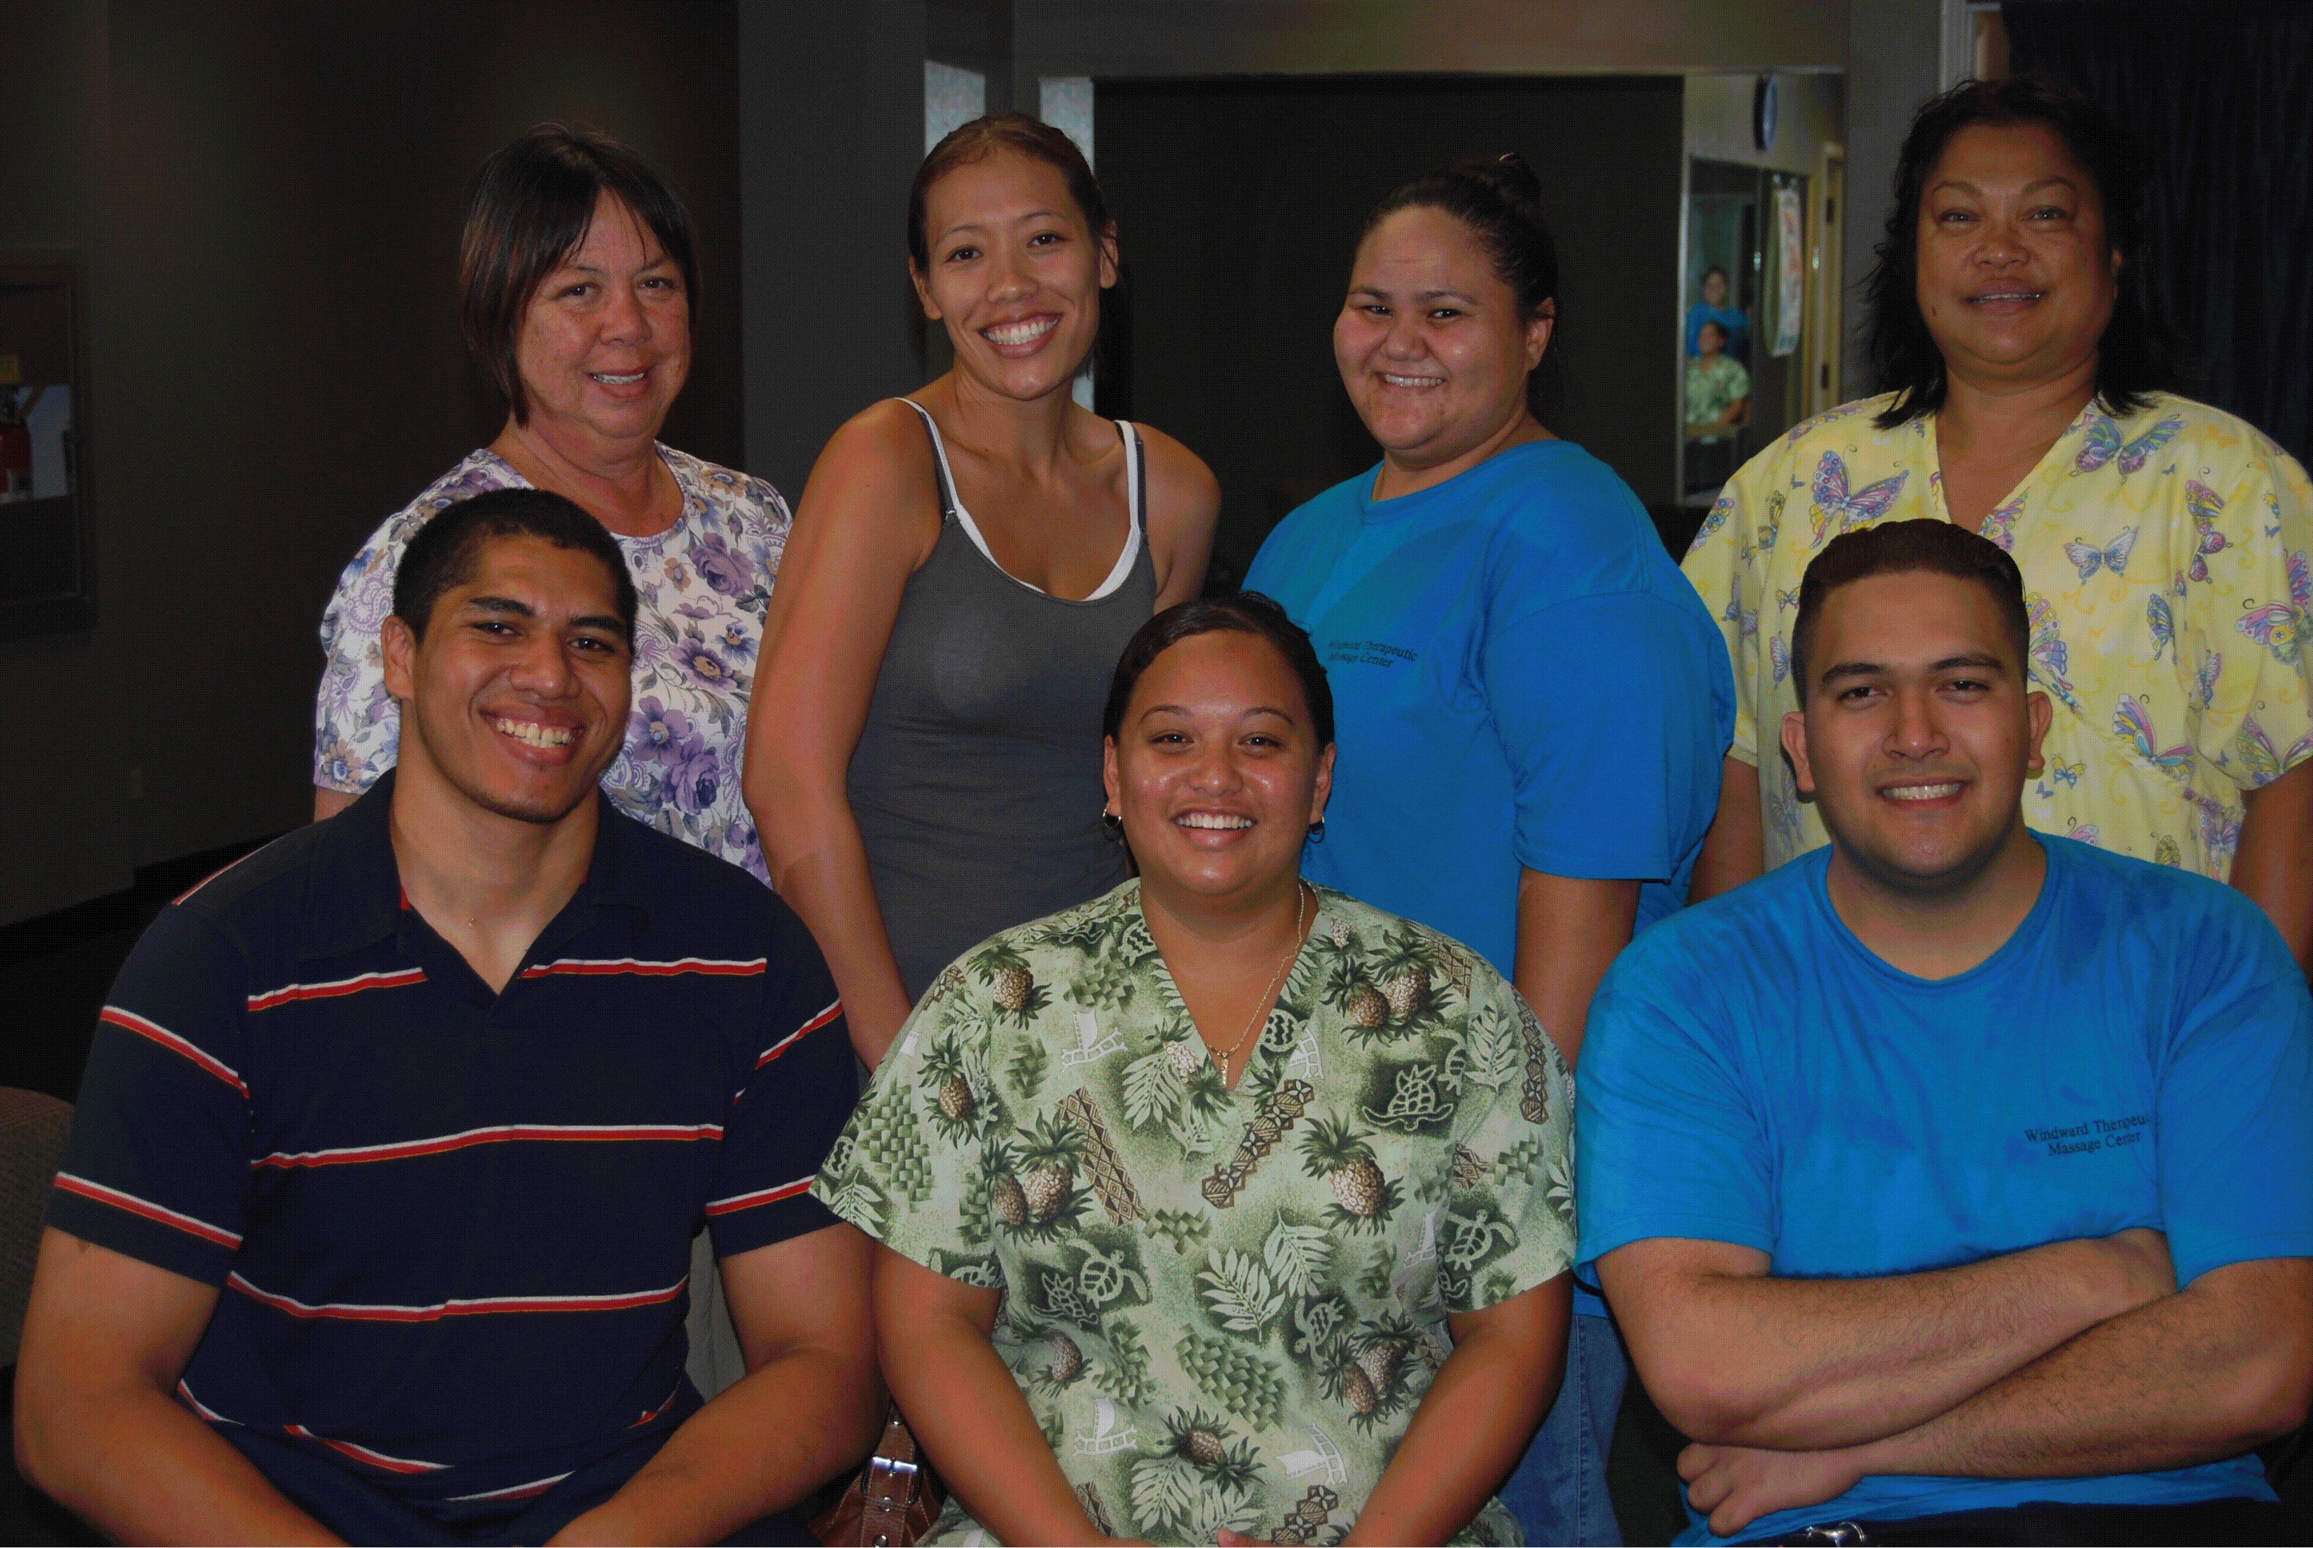
WTMC reserves the right to add, modify or discontinue programs of study, make changes to schedules and faculty, or adjust academic requirements/fees. These changes may be made without notice. Students will be notified immediately of any changes affecting their respective class directly.

Campus Information

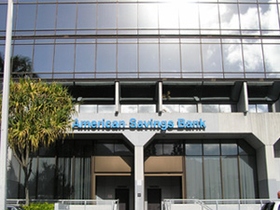
Windward Therapeutic Massage Center is located at 45-1144 Kamehameha Highway, Suite 200 in Kaneohe. Located on the Windward side of Oahu, this easy-to-access building is situated in the American Savings Bank building on the corner of Kahuhipa Street and Kamehameha Highway. The facility is 2,200 square foot within a professional business complex. The facility houses the administrative offices, student lounge, classroom, chiropractic office and the student and professional massage therapy clinic. The building is handicap accessible and has parking for students, and clients. Maximum class size is 12 students.

Faculty and Staff
Rochelle Featheran, LMT
Director of Education

Ashlyn Crawford, LMT
Instructor

Labryanna Kubo, RN, BSN, MNH, TNCC, CR, ACLS Instructor
Guest Speaker
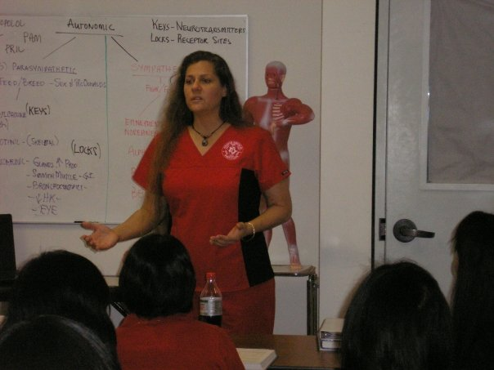
Misty Miyashiro, LMT
Instructor

Juleen Nakamoto, LMT
Instructor

Suzanne Garrett, LMT
Guest Speaker- Reflexology

Tate Rolfs, DC
Guest Speaker

Ricky D. Bautista, DC
Guest Speaker

Lawrence Connors, DC
Guest Speaker

Crystal Maxilom
Administration

Starla Frost
Administration Coordinator

